Experiment-12

Cursors

* Create a table with attributes students and marks.
* Insert values into the table.

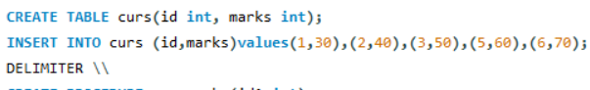

* Create a procedure, and fetch the marks of given id using a cursor.

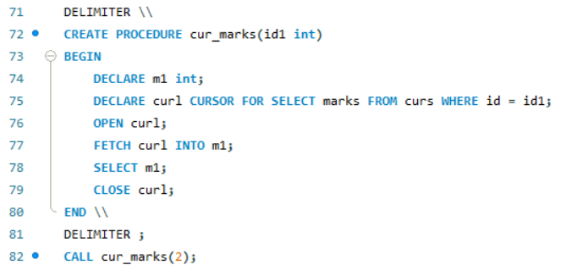

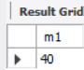

Create a procedure, and fetch the highest marks using a cursor

